## ****Data Analysis Report for AtliQ Grands****

**Tools : Python**

### ****1. Introduction****

AtliQ Grands is a hotel chain operating in major Indian cities such as Delhi, Mumbai, Bangalore, and Hyderabad. The chain includes various types of hotels like AtliQ Seasons, AtliQ Exotica, AtliQ Bay, and AtliQ Palace. Each hotel offers diverse room categories, including Standard, Elite, Premium, and Presidential.

Bookings are made through multiple platforms, including:

* Online platforms like MakeMyTrip, LogTrip, Tripster, and AtliQGrands.com.
* Offline bookings directly at the hotels.

All transactions, including booking details, revenue generated, and cancellations, are stored in the Booking database.

### ****2. Business Problems****

AtliQ Grands faces the following challenges:

* **Decline in revenue and market share:** Competition from rival hotel chains is eroding AtliQ Grands’ market position.
* **Suboptimal occupancy rates:** Inefficiencies in room bookings lead to missed revenue opportunities.
* **City-wise performance disparities:** Some cities perform worse in revenue generation compared to others.

To address these issues, AtliQ Grands’ management has decided to leverage **data analytics** for informed decision-making, aiming to increase revenue and regain market share.

### ****3. Approach****

#### ****3.1 Data Collection****

* The dataset is provided as **CSV files**, containing details such as:
  + Booking dates
  + Types of hotels
  + Types of rooms
  + Aggregated daily bookings
  + Detailed booking transactions (e.g., revenue, cancellations)

#### ****3.2 Data Cleaning and Exploration****

Key data cleaning and exploration steps include:

* **Handling missing values** to ensure data completeness.
* **Correcting data types** for accuracy in computations.
* **Resolving inconsistencies** in data formats or labels.

#### ****3.3 Data Transformations****

To prepare the data for analysis, the following transformations are applied:

* **Normalization:** Standardizing data to maintain consistency.
* **Merging:** Consolidating multiple datasets for holistic analysis.
* **Aggregation:** Summarizing data (e.g., daily, monthly, and yearly revenue) for key insights.

#### ****3.4 Data Analysis****

The analysis aims to address the business problems by answering key questions, using visualizations such as:

* **Pie Charts:** Distribution of revenue by booking platforms.
* **Bar Graphs:** City-wise performance comparisons.
* **Line Graphs:** Trends in revenue and occupancy rates over time.

### ****4. Insights and Key Findings****

#### ****4.1 Occupancy Percentage****

* Analysis of **occupancy rates** across room categories and cities reveals underperformance in certain room types and locations, indicating opportunities for targeted marketing or price adjustments.

#### ****4.2 Revenue Loss by City****

* Certain cities (e.g., Hyderabad and Bangalore) contribute significantly less revenue compared to others, requiring a focus on competitive pricing and local promotions.

#### ****4.3 Weekday vs. Weekend Occupancy****

* Weekends show consistently higher occupancy rates compared to weekdays, suggesting the need to introduce weekday offers to boost midweek bookings.

#### ****4.4 Platform-wise Performance****

* Online platforms like **MakeMyTrip** generate the highest revenue, whereas offline bookings and the AtliQGrands.com website underperform, indicating the need to improve the online booking experience on their proprietary platform.

### ****5. Recommendations****

Based on the analysis, the following actions are recommended:

1. **Optimize Pricing Strategies:**
   * Implement dynamic pricing to adjust room rates based on demand, especially for underperforming room types.
   * Offer targeted discounts or packages for weekdays and specific cities.
2. **Focus on Underperforming Cities:**
   * Launch localized marketing campaigns and promotions in cities with lower revenue generation, such as Bangalore and Hyderabad.
3. **Enhance the Online Booking Experience:**
   * Improve the usability and visibility of AtliQGrands.com to compete more effectively with third-party platforms like MakeMyTrip.
4. **Boost Occupancy Rates:**
   * Introduce loyalty programs and weekend deals to attract repeat customers.
   * Partner with corporate clients for bulk weekday bookings.
5. **Monitor Performance Regularly:**
   * Set up a dashboard to track revenue, occupancy rates, and platform performance monthly.

### ****6. Conclusion****

Through effective use of data analytics, AtliQ Grands can transition to data-informed decision-making to address declining revenue and market share. By optimizing occupancy rates, focusing on underperforming cities, and improving the online booking experience, AtliQ Grands can achieve sustainable growth and improve its competitive position in the market.

**Data Cleaning**

1. **In the number of guest columns there were some records with negative value I have removed those records.**



1. **There were outliers in revenue generated, first I have find out those records and removed it from the database.**

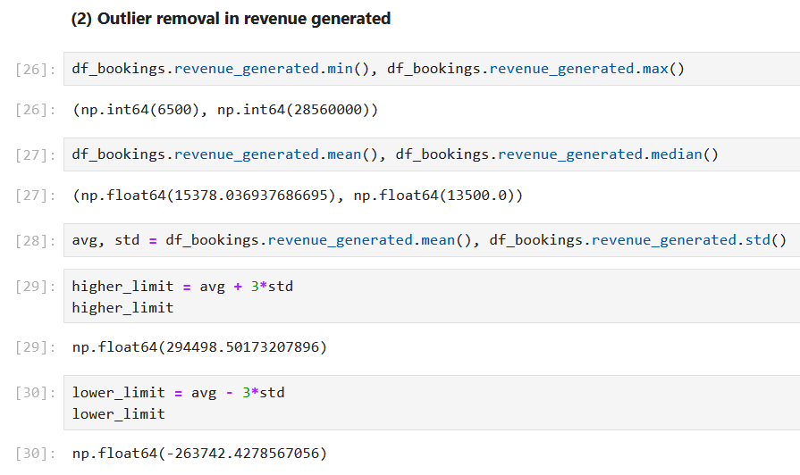

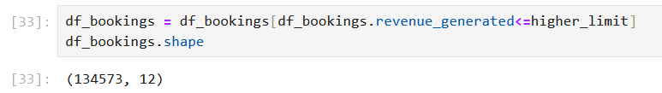

1. **Filling null values with median()**

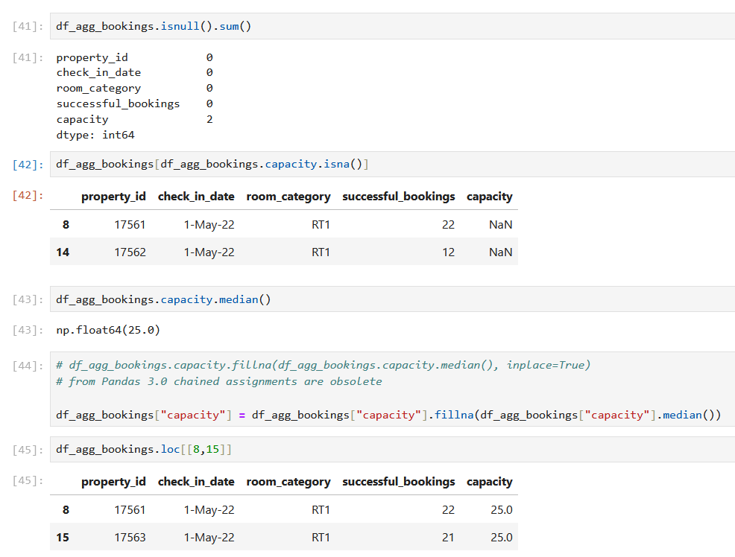

**Data Transformation**

1. **Create occupancy percentage column-**

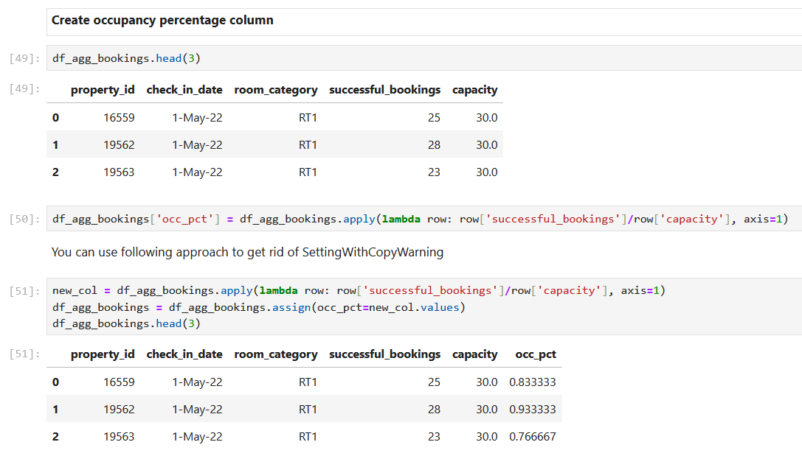

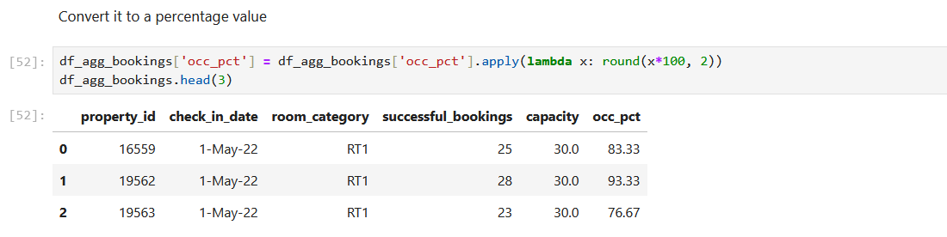

**Data transformations are essential for preparing data for analysis. Common examples include:**

**1. Creating New Columns:** For instance, adding a column like occ_pct to calculate occupancy percentage.

**2. Normalization:** Converting values, such as prices in USD and INR, to a common currency like INR.

**3. Merging Data:** Combining datasets, e.g., merging movie_df with revenue_df.

**4. Aggregation:** Calculating metrics like sum, average, mean, or median.

**Insights Generation**

1. **What is the average occupancy rate for each room category?**

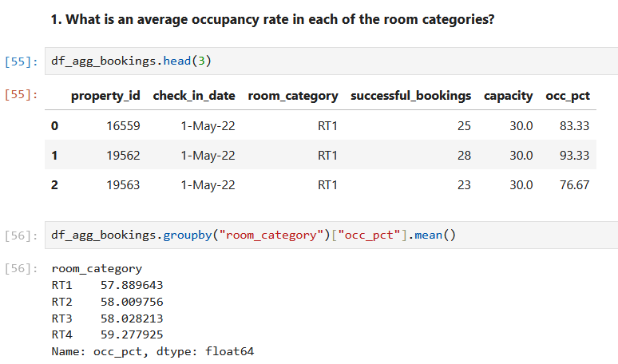

**What is the average occupancy rate for each city?**

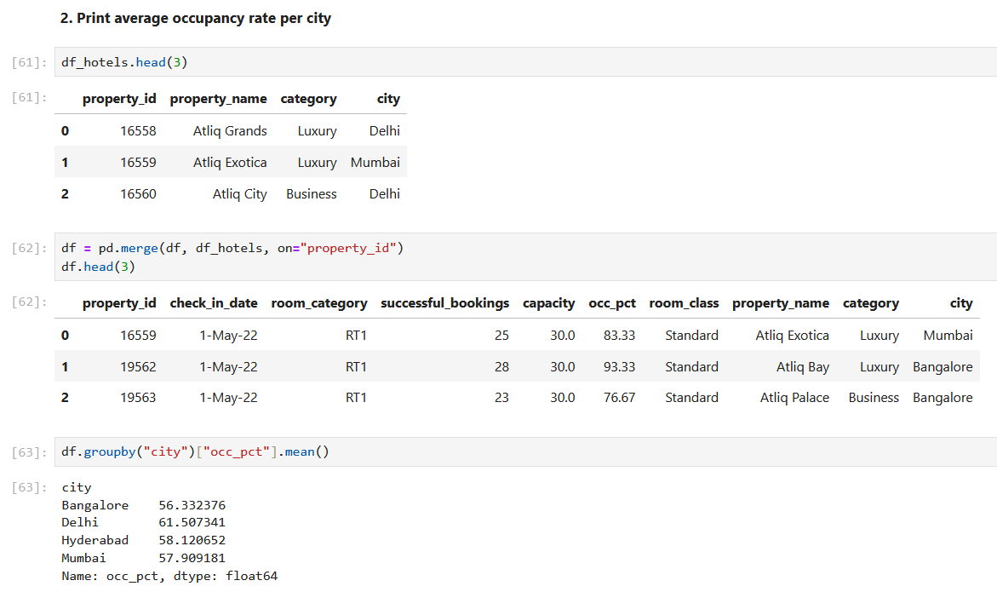

1. **Was occupancy better on weekdays or weekends?**

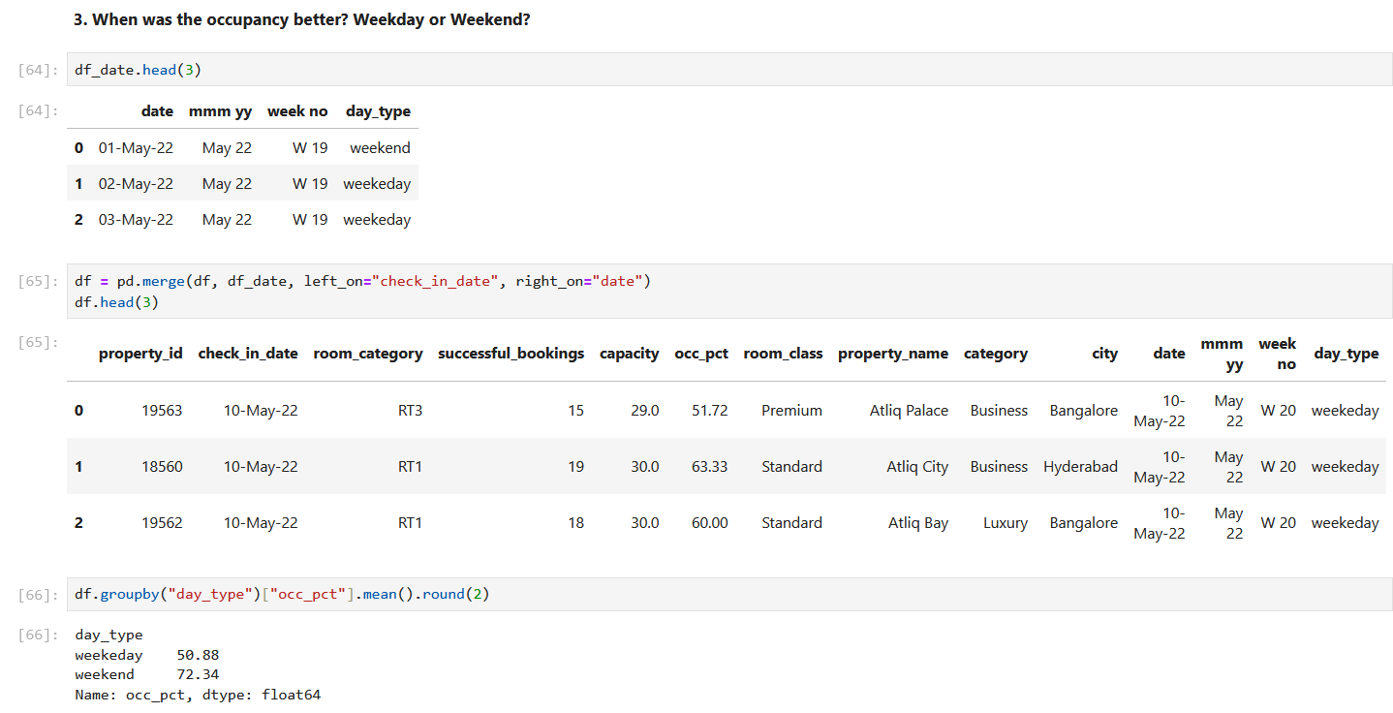

1. **What is the occupancy rate for different cities in the month of June?**

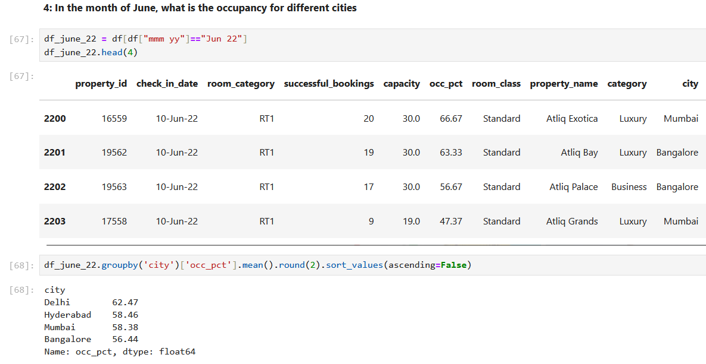

1. **What is the revenue realized for each booking platform?**

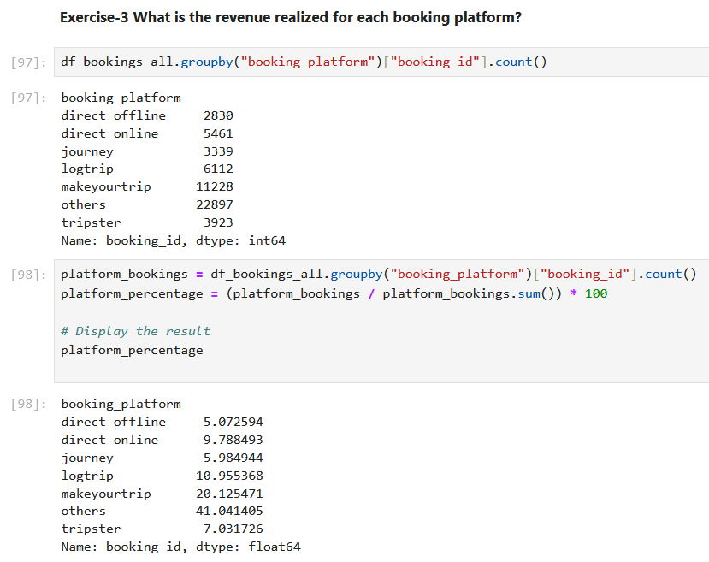

1. **What is the revenue realized for each city?**

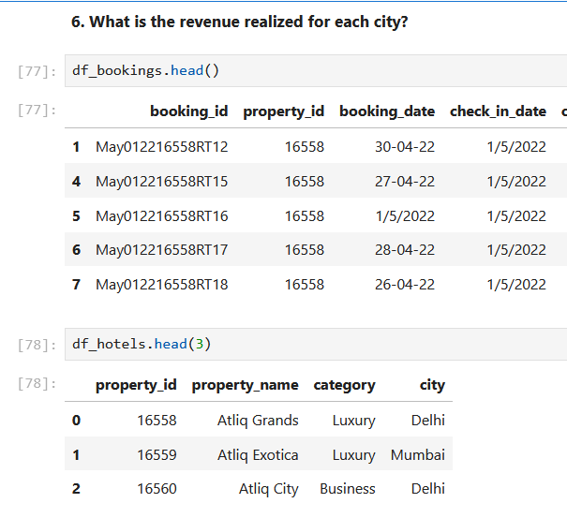

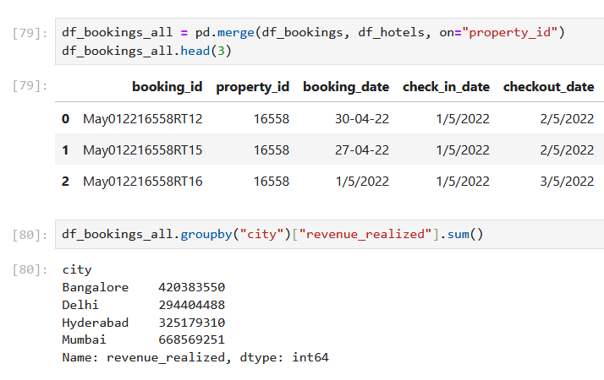

1. **What is the revenue realized for each hotel type?**

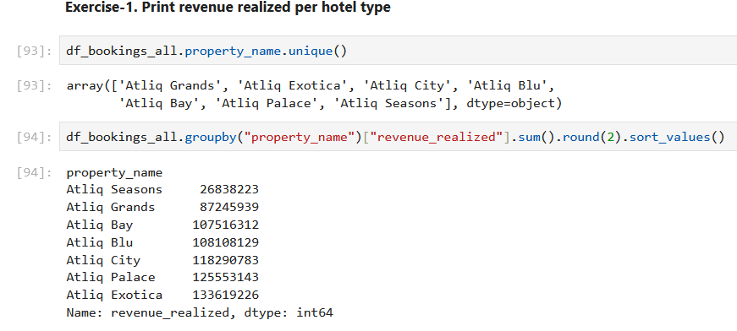

1. **What is the average rating for each city?**

